Database Design and implementation for HealU

**Goals and objectives**

The goal of this database system is to create a shortlist of doctor with the help of doctor’s specialty for the patients. User Submitted reviews and also manages online appointments for patients.

**Problems faced**

Healthcare remains one of the biggest issues at every time. It becomes hard to find suitable doctor also patient struggles to get the info for convenient appointment. Patient will be able to take informed decisions by reading reviews and by viewing the doctor’s vacant appointments through this system.

When a patient searches for specialized doctors in their area, they are provided with many doctors under the same specialization and area. This can be mitigated with the user submitted reviews to find the best doctor among them.

**Database solution for the Problem**

The purpose of the database to create and use searchable database where admin can manage doctor’s database and schedule properly form web based control panel. Doctor will be able to view their appointment list from this portal. Once the patients shortlists the doctors in their area according to the required

specialization, they can finalize the best doctor by comparing the reviews and ratings.

**Database Business Rules**

A business rule is a statement that imposes some form of constraint on a specific aspect of the database, such as the elements within a field specification for a particular field or the characteristics of a given relationship.

* Every user must have login Id and password.
* A patient can search by doctor’s specialty, zip code and insurance.
* Currently we are using Dhaka’s three areas.
* We have subdivided each areas in to two neighborhoods.
* Then each neighborhood will have one zip code assigned to it.
* Doctors are classified into four specialties.
* While searching for doctor in database, patient can select from 3 insurance plans.
* Each patient can provide reviews and ratings.
* Availability of reviews will help new patient to shortlist doctor.
* Each doctor will have available slots on particular days for online appointment.
* Patient can view doctor’s profile and schedule appointment as per his convenience.
* Patient with no insurance can also take advantage of this database.

**Flow Chart**

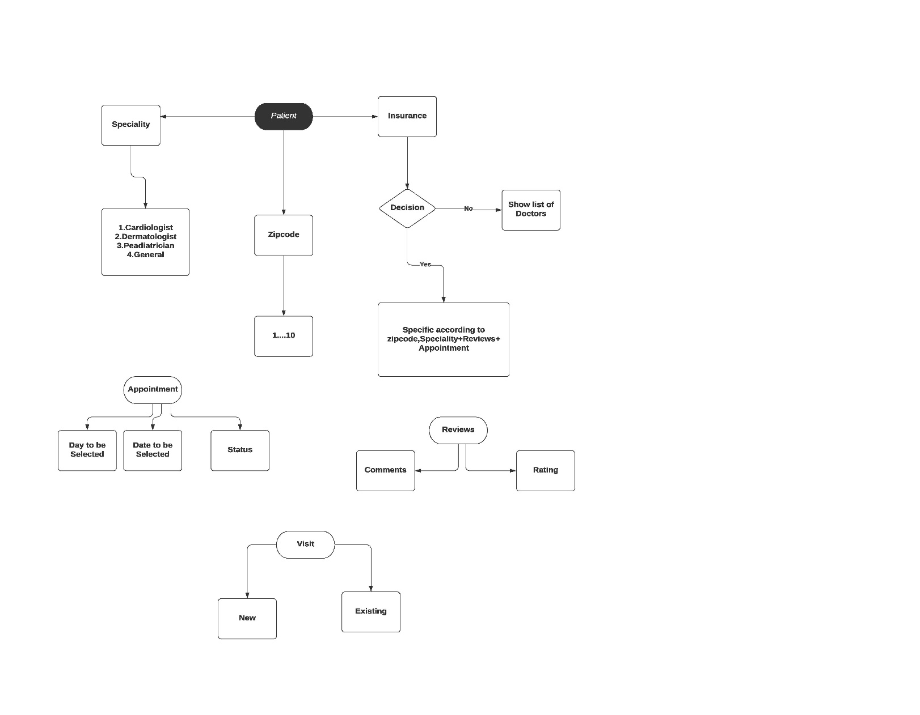

**Preliminary Entity Relationship Model**

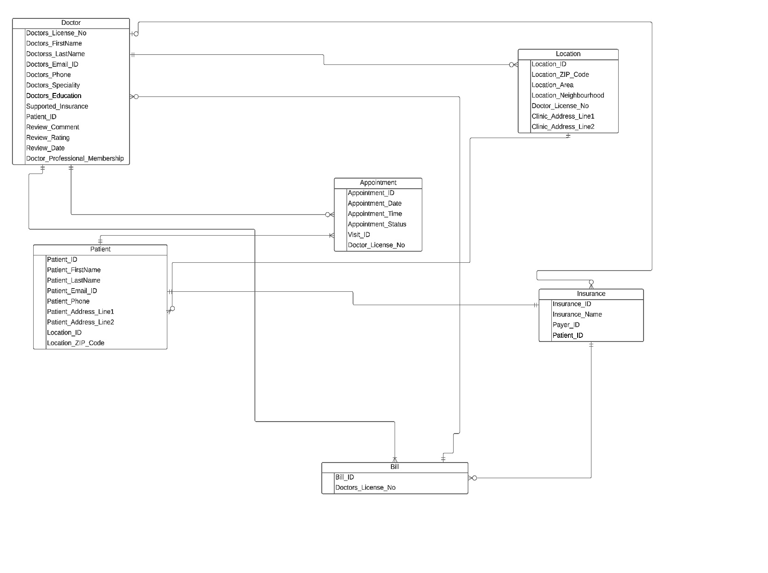

**Normalization Process**

**Denormalized Form**

Doctor-Doctor Review Relationship**:**

|  |  |  |  |  |
| --- | --- | --- | --- | --- |
| Doctors_License_No | Doctors_FirstName | Doctors_LastName | Doctors_Email_ID | Doctors_Phone |
| Doctor_Specialty | Doctor_Education | Supported_Insurance |  |  |
| Patient_ID | Review_Comment | Review_Rating | Review_Date |  |
| Doctor_Prof_Membership |  |  |  |  |

Patient-Appointment-Record:

|  |  |  |  |  |
| --- | --- | --- | --- | --- |
| Patient_ID | Patient_FirstName | Patient_LastName | Patient_Email_ID | Patient_Phone |
| Patient_Address_Line1 | Patient_Address_Line2 | Location_ID | Location_ZIP_Code |  |
| Appointment_ID | Appointment_Date | Appointment_Time | Appointment_Status | Visit_ID |
| Doctor_License_No |  |  |  |  |

Insurance-Bill:

|  |  |  |  |
| --- | --- | --- | --- |
| Insurance_ID | Insurance_Name | Payer_ID | Patient_ID |
| Bill_ID | Doctor_License_No |  |  |

Location-Location Mapping:

|  |  |  |  |
| --- | --- | --- | --- |
| Location_ID | Location_Zip_Code | Location_Area | Location_Neighborhood |
| Doctor_License_No | Clinic_Address_Line1 | Clinic_Address_Line2 |  |

**First Normal Form(1NF)**

Table is in 1NF form if the domain are indivisible and only single valued attributes are present.

Table format: No repeating groups and PK identified (Doctor_License_No, Review_Reference, Patient_ID, Appointment_ID, Insurance_ID, Location_ID, Location_Zip_Code)

Doctor-Doctor Review Relationship:

|  |  |  |  |  |
| --- | --- | --- | --- | --- |
| **Doctor_License_No** | Doctors_FirstName | Doctors_LastName | Doctors_Email_ID | Doctors_Phone |
| Doctor_Specialty | Doctor_Education | Supported_Insurance |  |  |
| Patient_ID | Review_Comment | Review_Rating | Review_Date |  |
| Doctor_Prof_Membership |  |  |  |  |

Patient-Appointment-Record:

|  |  |  |  |  |
| --- | --- | --- | --- | --- |
| **Patient_ID** | Patient_FirstName | Patient_LastName | Patient_Email_ID | Patient_Phone |
| Patient_Address_Line1 | Patient_Address_Line2 | Location_ID | Location_Zip_Code |  |
| **Appointment_ID** | Appointment_Date | Appointment_Time | Appointment_Status |  |
| Doctor_License_No |  |  |  |  |

Insurance-Bill:

|  |  |  |  |
| --- | --- | --- | --- |
| **Insurance_ID** | Insurance_Name | Payer_ID | Patient_ID |
| **Bill_ID** | Doctor_License_No |  |  |

Location-Location Mapping:

|  |  |  |  |
| --- | --- | --- | --- |
| **Location_ID** | Location_Zip_Code | Location_Area | Location_Neighborhood |
| Doctor_License_No | Clinic_Address_Line1 | Clinic_Address_Line2 |  |

**Second Normal Form(2NF)**

The tables should be in 1NF and have no partial dependencies. Means no non-prime attribute (attributes which are not part of any candidate key) is dependent on any proper subset of any candidate key of the table.

Doctor-Doctor Review Relationship:

Doctor

|  |  |  |  |  |
| --- | --- | --- | --- | --- |
| **Doctor_License_No** | Doctors_FirstName | Doctors_LastName | Doctors_Email_ID | Doctors_Phone |
| Doctor_Specialty | Doctor_Education | Supported_Insurance |
| Patient_ID | Review_Commen | Review_Rating | Review_Date |

Doctor Profile

|  |  |  |
| --- | --- | --- |
| **Doctor_Prof_Membership_ID** | **Doctor_License_No** | Doctor_Prof_Membership |

Patient-Appointment:

Patient

|  |  |  |  |  |
| --- | --- | --- | --- | --- |
| **Patient_ID** | Patient_FirstName | Patient_LastName | Patient_Email_ID | Patient_Phone |
| Patient_Address_Line1 | Patient_Address_Line2 | Location_ID | Location_Zip_Code |  |

Appointment

|  |  |  |  |  |
| --- | --- | --- | --- | --- |
| **Appointment_ID** | Appointment_Date | Appointment_Time | Appointment_Status | Visit_ID |
| Doctor_License_No | Patient_ID |  |  |  |

Visit:

|  |  |  |
| --- | --- | --- |
| **Visit_ID** | Visit_Purpose | Record_ID |

Medical Record:

|  |  |  |
| --- | --- | --- |
| **Record_ID** | Patient_ID | Appointment_ID |

Insurance-Bill:

Insurance

|  |  |  |  |
| --- | --- | --- | --- |
| **Insurance_ID** | Insurance_Name | Payer_ID | Patient_ID |

Bill

|  |  |  |
| --- | --- | --- |
| **Bill_ID** | Doctor_License_No | Insurance_ID |

Payment

|  |  |
| --- | --- |
| **Payment_ID** | Bill_ID |

Location-Location Mapping

Location

|  |  |  |  |
| --- | --- | --- | --- |
| **Location_ID** | Location_Zip_Code | Location_Area | Location_Neighborhood |
| **Doctor_License_No** | Clinic_Address_Line1 | Clinic_Address_Line2 |  |

**Third Normal Form (3NF) and Boyce-Codd Normal Form (BCNF)**

A relation is in third normal form, if there is **no transitive dependency** for non-prime attributes as well as it is in second normal form.  A relation is in BCNF iff in every non-trivial functional dependency X –> Y, X is a super key.

Doctor-Doctor Review Relationship:

Doctor

|  |  |  |  |  |
| --- | --- | --- | --- | --- |
| **Doctor_License_No** | Doctors_FirstName | Doctors_LastName | Doctors_Email_ID | Doctors_Phone |
| Doctor_Specialty | Doctor_Education | Supported_Insurance |  |  |

Review

|  |  |  |  |  |
| --- | --- | --- | --- | --- |
| **Review_Reference** | Patient_ID | Review_Comment | Review_Rating | Review_Date |

Doctor Profile

|  |  |  |
| --- | --- | --- |
| **Doctor_Prof_Membership_ID** | Doctor_License_No | Doctor_Prof_Membership |

Patient-Appointment:

Patient

|  |  |  |  |  |
| --- | --- | --- | --- | --- |
| **Patient_ID** | Patient_FirstName | Patient_LastName | Patient_Email_ID | Patient_Phone |
| Patient_Address_Line1 | Patient_Address_Line2 | Location_ID | Location_Zip_Code |  |

Appointment

|  |  |  |  |  |
| --- | --- | --- | --- | --- |
| **Appointment_ID** | Appointment_Date | Appointment_Time | Appointment_Status | Visit_ID |
| Doctor_License_No |

Visit:

|  |  |  |
| --- | --- | --- |
| **Visit_ID** | Visit_Purpose | Record_ID |

Medical Record:

|  |  |  |
| --- | --- | --- |
| **Record_ID** | Patient_ID | Appointment_ID |

Insurance-Bill:

Insurance

|  |  |  |  |
| --- | --- | --- | --- |
| **Insurance_ID** | Insurance_Name | Payer_ID | Patient_ID |

Bill

|  |  |  |
| --- | --- | --- |
| **Bill_ID** | Doctor_License_No | Insurance_ID |

Payment

|  |  |
| --- | --- |
| **Payment_ID** | Bill_ID |

Location-Location Mapping:

Location

|  |  |  |  |
| --- | --- | --- | --- |
| **Location_ID** | Location_Zip_Code | Location_Area | Location_Neighborhood |

Location mapping

|  |  |  |  |  |
| --- | --- | --- | --- | --- |
| **Location_ID** | **Location_Zip_Code** | **Doctor_License_No** | Clinic_Address_Line1 | Clinic_Address_Line2 |

**Entities After Normalization**

|  |  |
| --- | --- |
| Entity | Entity Description |
| **Doctor** | person who is licensed to practice medicine |
| **Doctor_Review** | Visiting doctor experience from patient |
| **Doctor_Profile** | Doctor details for helping patient matching |
| **Patient** | A person who is under medical care or treatment |
| **Appointment** | Doctor for whom patient has been appointed |
| **Visit** | Object of doctor office visit |
| **Medical_Record** | Patient physical or mental problem history |
| **Insurance** | Coverage that covers the cost of an insured individual's medical and surgical expenses. |
| **Bill** | Fee generated after visiting doctor |
| **Payment** | Payment for bill |
| **Location** | Address where patient locates |
| **Location_Mapping** | Doctor’s office where is convenience for patient choosing |

**Relationships between Entities after Normalization**

|  |  |  |  |  |  |  |
| --- | --- | --- | --- | --- | --- | --- |
| **Entities**   |  |  | | --- | --- | | **Parent** | **Child** | | **Relation** | **Cardinalities**   |  |  | | --- | --- | | **Min** | **Max** | |
| |  |  | | --- | --- | | **Doctor** | **Doctor_Profile** | | **Doctor** | **Doctor_Review** | | **Doctor** | **Location_Mapping** | | **Doctor** | **Bill** | | **Doctor** | **Appointment** | | **Patient** | **Doctor_Review** | | **Patient** | **Insurance** | | **Patient** | **Appointment** | | **Patient** | **Medical_Record** | | **Visit** | **Appointment** | | **Appointment** | **Medical_Record** | | **Insurance** | **Bill** | | **Bill** | **Payment** | | **Location** | **Location_Mapping** | | **Medical_Record** | **Visit** | | |  | | --- | | **Identify** | | **Non-Identify** | | **Identify** | | **Non-Identify** | | **Non-Identify** | | **Identify** | | **Non-Identify** | | **Non-Identify** | | **Non-Identify** | | **Non-Identify** | | **Non-Identify** | | **Non-Identify** | | **Non-Identify** | | **Identify** | | **Non-Identify** | | |  |  | | --- | --- | | **1:1** | **1:1** | | **1:1** | **1:M** | | **1:1** | **1:1** | | **1:1** | **1:M** | | **1:1** | **1:M** | | **1:1** | **1:M** | | **1:1** | **1:1** | | **1:1** | **1:0** | | **1:0** | **1:0** | | **1:1** | **1:M** | | **1:1** | **1:M** | | **1:1** | **1:M** | | **1:1** | **1:M** | | **1:1** | **1:M** | | **1:0** | **1:0** | |

**Final Entity Relationship Diagram**

